CURRICULUM VITAE 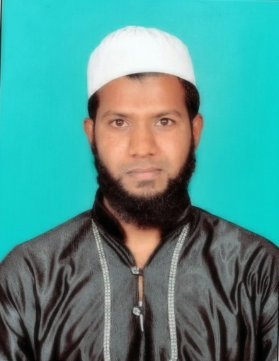

Mobile: 9175049287
9666872450
BEPARI. SALAM MUSA Email: Dovesalam@gmail.com
Skype: Saalam.Gazi1

CAREER OBJECTIVE:

Looking forward to join a progressive organization to pursue a successful career by utilizing my skills and abilities to the maximum extent with full potential. I am confident that I can achieve a level of performance which is nothing short to perfection and that your organization would provide the scope for such a growth and development.

EDUCATIONAL QUALIFICATION:

GRADUATION: - B. B.A from Vasant Rao Dada patil.Institute of Management
studies & Research, Sangli. (VPIM) college (MH) in year 2013.
INTERMEDIATE: - In I.com from Shikshan Mahrashi Dr. Bapuji Salunkhe (ACS)
College Miraj (MH) in the year 2009.
MATRICULATION: - From New English School Miraj (MH) in year 2007.

SOFTWARE/HARDWARE SKILLS:

OPERATING SYSTEM : Dos, Windows XP/Vista/7/8/9 Windows Server 2012
TOOLS : Internet Concepts, MS-Office, Hardware
Networking, Firewall, CCNA, Linux, MCSE

HARDWARE SYSTEM/CELL PHONE:
Desktop assembling/disassembling, Laptop
Assembling/disassembling, Chip level repairing, cell phone
Assemble/disassemble, Cell phone chip level repairing, Tablet
Chip level chip level, printer repairing, Monitors repairing.

WORK EXPERIENCE:

2 years Experience as a hardware support engineer & coordinator with Part Time & full time adjusting on the bases of S.S.C & H.S.C Certificates at RESOURCE ADVANCE COMPUTER EDUCATION INSTITUTE MIRAJ.
& 3 months Experience as a online sales Representative in RELAINCE

ACADEMIC PROJECT:

Project Name : The study of Deposits & Loans in Axis Bank Ltd., of Miraj Branch
Duration : 3 Months
Organization : Axis Bank (Miraj Brach)
PROJECT DESCRIPTION:
The Credit Department of Bank collects deposits from the Public and also from the private companies. The credit Department of the Bank depends upon the funds so increase in deposits each year is the indication of stability & goodwill of the Bank. Axis bank Ltd., is large type of banking orienting.
The credit Department second major function is giving loans to needy people & actual use to persons so Credit Department provides loans to the needy people fulfill their needs & wants satisfaction.
When a person getting advance in a lump sum which can be paid wholly or partly it is called as Loan. Loans also render a great help in Economic Development. The loans play an important role in economical development of the country. The credit Department of this bank Provides Loans to the Large types of Rural Companies to make such effort & task to Develops.
STRENGTHS:
- Flexibility and Adoptability to the Working environment
- Self-Motivated with Leadership Skills
- Self-Confident, Cool Minded with Positive Attitude

PERSONAL DETAILS:

Father Name : Musa Hanif Bepari
Date of Birth : 27th July 1989
Gender : Male
Nationality : Indian
Languages Known : English, Hindi, Marathi

PLACE : MIRAJ
(SALAM BEPARI)

